Assignment 7.1

Name : Y Vasudev

Batch : DA with R , Excel and Tableau

1. Histogram for all variables in a dataset mtcars. Write a program to create histograms for all columns.

> mtcars

mpg cyl disp hp drat wt qsec vs am gear carb

Mazda RX4 21.0 6 160.0 110 3.90 2.620 16.46 0 1 4 4

Mazda RX4 Wag 21.0 6 160.0 110 3.90 2.875 17.02 0 1 4 4

Datsun 710 22.8 4 108.0 93 3.85 2.320 18.61 1 1 4 1

Hornet 4 Drive 21.4 6 258.0 110 3.08 3.215 19.44 1 0 3 1

Hornet Sportabout 18.7 8 360.0 175 3.15 3.440 17.02 0 0 3 2

Valiant 18.1 6 225.0 105 2.76 3.460 20.22 1 0 3 1

Duster 360 14.3 8 360.0 245 3.21 3.570 15.84 0 0 3 4

Merc 240D 24.4 4 146.7 62 3.69 3.190 20.00 1 0 4 2

Merc 230 22.8 4 140.8 95 3.92 3.150 22.90 1 0 4 2

Merc 280 19.2 6 167.6 123 3.92 3.440 18.30 1 0 4 4

Merc 280C 17.8 6 167.6 123 3.92 3.440 18.90 1 0 4 4

Merc 450SE 16.4 8 275.8 180 3.07 4.070 17.40 0 0 3 3

Merc 450SL 17.3 8 275.8 180 3.07 3.730 17.60 0 0 3 3

Merc 450SLC 15.2 8 275.8 180 3.07 3.780 18.00 0 0 3 3

Cadillac Fleetwood 10.4 8 472.0 205 2.93 5.250 17.98 0 0 3 4

Lincoln Continental 10.4 8 460.0 215 3.00 5.424 17.82 0 0 3 4

Chrysler Imperial 14.7 8 440.0 230 3.23 5.345 17.42 0 0 3 4

Fiat 128 32.4 4 78.7 66 4.08 2.200 19.47 1 1 4 1

Honda Civic 30.4 4 75.7 52 4.93 1.615 18.52 1 1 4 2

Toyota Corolla 33.9 4 71.1 65 4.22 1.835 19.90 1 1 4 1

Toyota Corona 21.5 4 120.1 97 3.70 2.465 20.01 1 0 3 1

Dodge Challenger 15.5 8 318.0 150 2.76 3.520 16.87 0 0 3 2

AMC Javelin 15.2 8 304.0 150 3.15 3.435 17.30 0 0 3 2

Camaro Z28 13.3 8 350.0 245 3.73 3.840 15.41 0 0 3 4

Pontiac Firebird 19.2 8 400.0 175 3.08 3.845 17.05 0 0 3 2

Fiat X1-9 27.3 4 79.0 66 4.08 1.935 18.90 1 1 4 1

Porsche 914-2 26.0 4 120.3 91 4.43 2.140 16.70 0 1 5 2

Lotus Europa 30.4 4 95.1 113 3.77 1.513 16.90 1 1 5 2

Ford Pantera L 15.8 8 351.0 264 4.22 3.170 14.50 0 1 5 4

Ferrari Dino 19.7 6 145.0 175 3.62 2.770 15.50 0 1 5 6

Maserati Bora 15.0 8 301.0 335 3.54 3.570 14.60 0 1 5 8

Volvo 142E 21.4 4 121.0 109 4.11 2.780 18.60 1 1 4 2

> hist(mtcars$disp)

> hist(mtcars$mpg)

> hist(mtcars$cyl)

> hist(mtcars$hp)

> hist(mtcars$drat)

> hist(mtcars$wt)

> hist(mtcars$qsec)

> hist(mtcars$vs)

> hist(mtcars$ am)

> hist(mtcars$gear)

> hist(mtcars$carb)

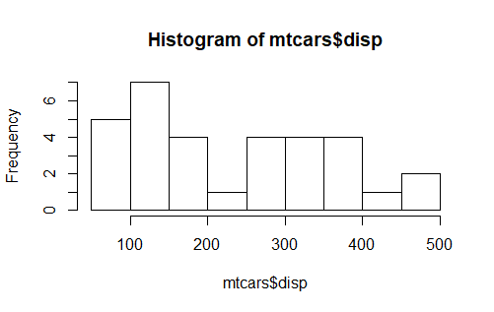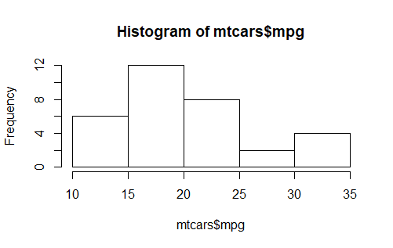

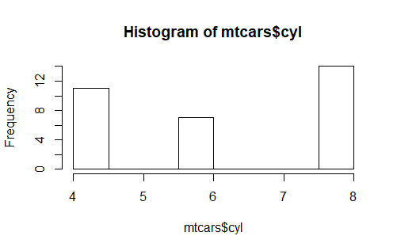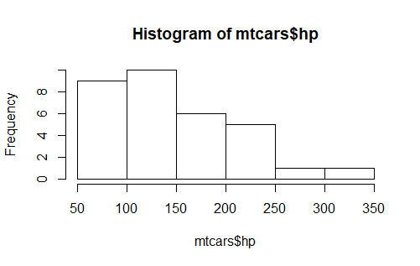

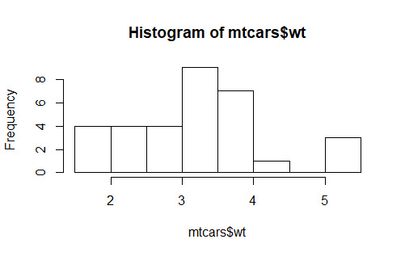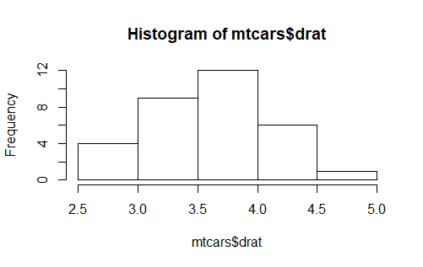

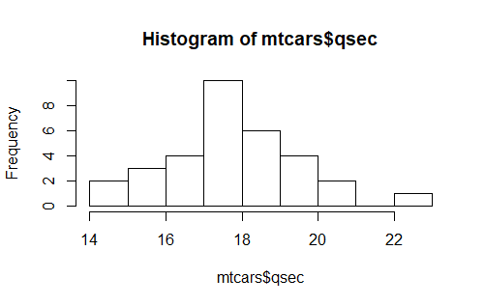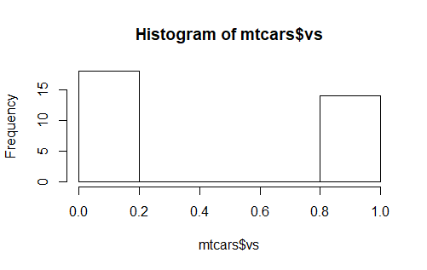

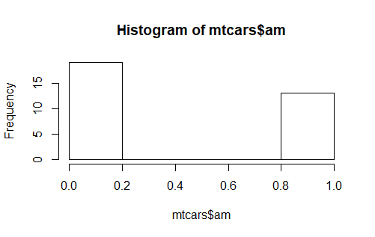 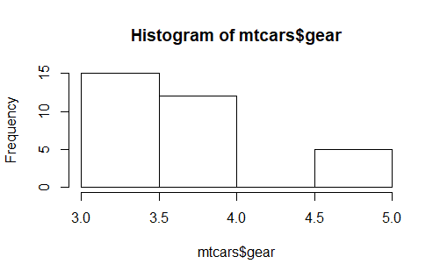

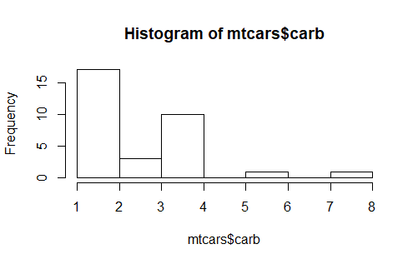

2. Check the probability distribution of all variables in mtcars

> colnames(mtcars)

[1] "mpg" "cyl" "disp" "hp" "drat" "wt" "qsec" "vs" "am" "gear" "carb"

> par(mfrow=c(3,4))

> par(pin=c(1, 1))

>

> for(i in 1:ncol(mtcars)) {

+ plot(density(mtcars[,i]), main=names(mtcars)[i])

+ }

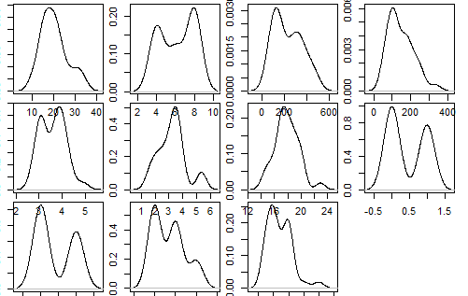

3. Write a program to create boxplot for all variables.

> colnames(mtcars)

[1] "mpg" "cyl" "disp" "hp" "drat" "wt" "qsec" "vs" "am" "gear" "carb"

> par(mfrow=c(3,4))

> par(pin=c(1, 1))

>

> for(i in 1:ncol(mtcars)) {

+ boxplot((mtcars[,i]), main=names(mtcars)[i])

+ }

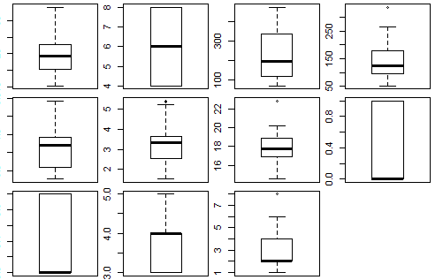

OR

> boxplot(mtcars$mpg)

> boxplot(mtcars$cyl)

> boxplot(mtcars$disp)

> boxplot(mtcars$hp)

> boxplot(mtcars$drat)

> boxplot(mtcars$wt)

> boxplot(mtcars$qsec)

> boxplot(mtcars$vs)

> boxplot(mtcars$am)

> boxplot(mtcars$gear)

> boxplot(mtcars$carb)

